CHAPTER

10

Sexual Recruitment of the Corals Favia fragum and Agaricia humilis in a 30 m³ Exhibit Aquarium
Species-Specific Limitations and Implications on Reproductive Ecology

INTRODUCTION

Today’s public aquariums show a continuous trend to build larger exhibits (i.e. see Alvarez and Garcia, 2001; Janse and Wensing, 2001) offering a great experience to the visitor and new opportunities for research. Multi-species exhibits like live coral aquariums allow us to study the ecology of displayed animals in a relatively well defined biological and non-biological environment (Carlson, 1999; see also Adey and Loveland, 1998). In the past, the sudden appearance of juvenile scleractinian corals in exhibit tanks, in particular cases the result of sexual reproduction, has been observed for some species (see chapter 2). Scientific investigation to gain better understanding of this phenomenon have hardly been carried out. The process described in this chapter has been defined in the field as ‘coral recruitment’ (see chapter 1). When recruitment occurs, a noticeable decrease of mortality can be observed (Sorokin, 1995) as a result of juveniles with increasing size being less affected by environmental factors such as sedimentation (Wittenberg and Hunte, 1992) and algal growth (McCook et al., 2001). Recruitment rate can be understood as a measure the reproductive success under local environmental conditions. These conditions can particularly influence gamete production, fertilization, planktonic stage and settlement of larvae, and early life stages of settlers.
In this chapter, I have investigated the process of coral recruitment in a closed-system exhibit aquarium. I observed recruits of Favia fragum and Agaricia humilis after field-collected specimens were temporarily maintained in a 30m³ closed-system mesocosm (for definition see Adey and Loveland, 1998). One and half years later, I observed recruitment of the F2 generation of F. fragum. I analyzed the population structure of both species and estimated the recruitment rate in relation to environmental factors and depending on species-specific reproductive behavior.

METHODS

Aquarium System

Technical properties
The exhibit was 19 months in operation (start April 2000) when parental colonies of the studied species were introduced. The tank (8.0 x 1.6 x 2.3 m; L x W x H) has a gross water volume of 29,440 l with additionally 11,300 L water volume of the life support system (= LSS; Intensive Aquaculture Technology LTD., U.K.). Artificial rockwork made from a sand and concrete mixture sealed by acid stain (Dave Manwarren Corp., USA) takes approx. 25 % of the total tank volume. At the start approx. 300 kg of ‘Live Rock’ (coral reef substrate containing all its associated organisms; here: aquacultured in Florida) was introduced. After the artificial rockwork had been covered with marine algae and other benthic organisms most of it was removed again.
A residence time of 1.8 hr was calculated before water passes again the LSS. First the water is collected in a sump tank (2.5 x 1.5 m; diameter x H) to which a protein skimmer (1.8 x 2.5 m; diameter x H; flow rate 20,000 l h⁻¹) and a heat exchanger are connected in separate bypasses. Before water is pumped into the exhibit tank it has to pass 2 sand pressure filters. No ozone or UV sterilization are applied.
In the exhibit water motion is generated by controlling water circulation by means of pneumatic valves connected to a digital timer (the valves were installed in the later phase of the study period) and an independent circulation system: three automatic siphon devices (volume 500 L) are placed approx. 2.5 m above the water surface of the exhibit. The devices principally function according to the Carlson Surge Device designed by Bruce Carlson, Waikiki Aquarium, Hawaii (for further details see Delbeek & Sprung 1996). Approx. every 10 minutes the devices unload their complete volume in less than 30 s creating a strong and alternating surge. A total flow of approx. 50,000 l h⁻¹ is generated in the tank.
Regarding lighting, we use five 2 KW HQI 6,000 K (daylight spectrum) and 1 KW HQI 6,000 K (replaced by 1 KW HQI 20,000 K = blue spectrum at the end of the study period) of each in the deeper zones, and seven 400 W HQI 10,000 K (intermediate between daylight and blue spectrum) for variable use in the shallow zones and behind the artificial rock wall of the tank (total: ± 1.39 KW m⁻²). The 2 KW bulbs operate daily for 5 hr, all others for 12 hr. All lamps are switched on and off successively in pairs of two. The tank is neither exposed to artificial nor to natural moonlight. A constant nocturnal lighting from surrounding building safety installations partly illuminates the tank (0.217 ± 0.106 μmol m⁻² s⁻¹; see chapter 6).
Approx. 25 % of the total water volume of the system (33,380 L) is monthly exchanged due to sand filter backwashing. We use natural seawater, regularly collected by tank ships offshore in the Atlantic Ocean. Two calcium reactors (Jetstream 2, Schuran Seawater Equipment, Germany) are used and commercial water additives are regularly added to supply certain elements, which are continuously consumed especially by corals. Temperature and salinity are constantly kept at 26 ºC and at 36 ‰.

Live Stock
The mesocosm aquarium exclusively exhibits organisms from the Caribbean. Here I only list organisms, which might be relevant for the present study.
The benthos is mainly dominated by algae (crustose coralline algae, green turf algae and cyanobacteria) and by cnidarians like scleractinians (Agaricia humilis, Diploria strigosa, Eusmilia fastigiata, Favia fragum, Madracis spp., Meandrina meandrites, Montastraea annularis, Porites asteroides, Siderastraea siderea), gorgonians (Eunicea spp., Gorgonia vandalia, Muricea muricata, Pterogorgia citrina, Pseudoptergogorgia spp., Pleaxaurella spp.), and anemones (Condylactis gigantea).
Fish can be divided into 3 relevant groups: (1) herbivorous, (2) planktivorous and (3) coralivorous. (1) The tank contains a group of 18 Acanthuridae (Acanthurus bahianus, A. coeruleus) and 15 Scartella cristata. (2) and (3) During the study period only three planktivorous Gramma loreto were living in the tank and a couple of the Indo Pacific butterfly fish Chelmon rostratus was temporarily introduced to remove Aiptasia sp. Consumption of coral plankton by other fish (e.g. Labridae) may not be completely excluded, due to possible changes in feeding habits in captivity.
For additional algal control 250 hermit crabs (Paguristes spp.), 585 snails (Astraea spp., Cerithium litteratum, Nodolittorina tuberculata) and 335 sea urchins (Echinometra lucunter) were successively introduced.
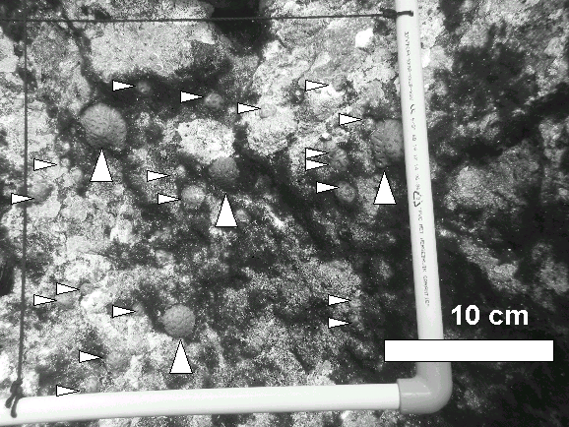
Fig. 1 High local densities of the F1 and F2 generations of Favia fragum, here in a sub-square of a large transect (F1 specimens: vertical large arrows; F2 specimens: horizontal small arrows).

Parental Corals
In November 2001, 30 adult colonies of each, Agaricia humilis and Favia fragum were collected at the fringing reef of Curaçao and transported to Rotterdam Zoo using a modified protocol of chapter 3. After arrival at Rotterdam Zoo, corals were acclimated to local water conditions (for protocol see chapter 3) and placed in the coral exhibit onto polystyrene grids at the back part of the tank behind the artificial rock wall, not visible to the visitor. The coral specimens that were aimed for the experiments of this dissertation stayed in the exhibit tank until the experimental tanks in the laboratory were fully operational. After 3 months all specimens were removed; no additional specimens of both species were present in the exhibit at any time.

Population Assessment of Juveniles

I aimed at assessing (1) the total number of recruits and (2) the mean density as standard values for possible comparison with other studies. I used 2 different methods: (1) the surface relief of the tank was divided into fields defined by landmarks and surface orientation. All visible specimens of the F1 and F2 generation of both species were counted 3 times for each field on subsequent days by one person positioned in the public area in front of the acrylic panel. In order to calculate the mean density per field, the surface of each field was measured 2-dimensionally (AxioVision 3.1, Carl Zeiss Vision GmbH Germany). (2) transects of 50 x 50 cm and 25 x 25 cm (subdivided into 4 squares, each 25 x 25 cm and 12.5 x 12.5 cm) were placed randomly on the artificial rockwork, a digital picture of each transect and of each square was taken (Canon Powershot G2; Ikelite Digital Underwater Housing) by a diver, and the amount of colonies per surface unit was then counted (Adobe Photoshop 7.0). The surface area and max. diameter of the transected colony was measured digitally whenever the position of the specimen on the photograph ensured an appropriate measurement (AxioVision 3.1, Carl Zeiss Vision GmbH Germany). The large transects were used to assess the F1, the small transects served for the F2 generations. Additionally, the max. diameter of 10 colonies was monthly measured for a duration of 5 months. These colonies were situated horizontally behind the artificial rock wall of the exhibit.

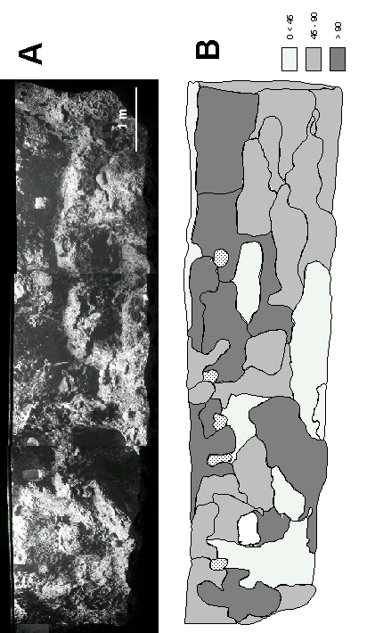
Fig. 2 A) Overview of the exhibit made from a series of 5 photographs. B) Map showing distribution of fields with different surface orientation (0º < 45º, 45º-90º, > 90º). Note: since fields were defined using photographs and the exhibit itself, Fig. 2A does not consequently reflect the distribution of the fields in Fig. 2B.

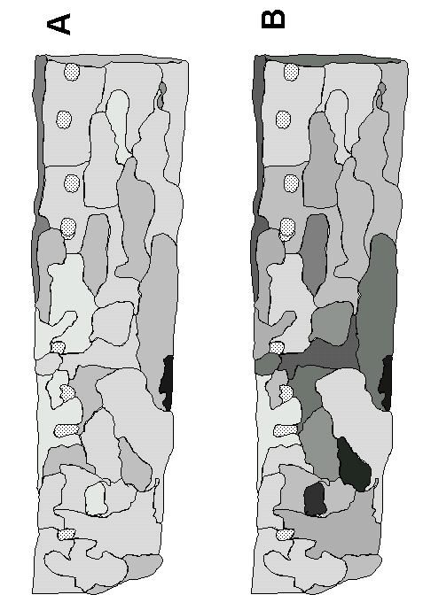
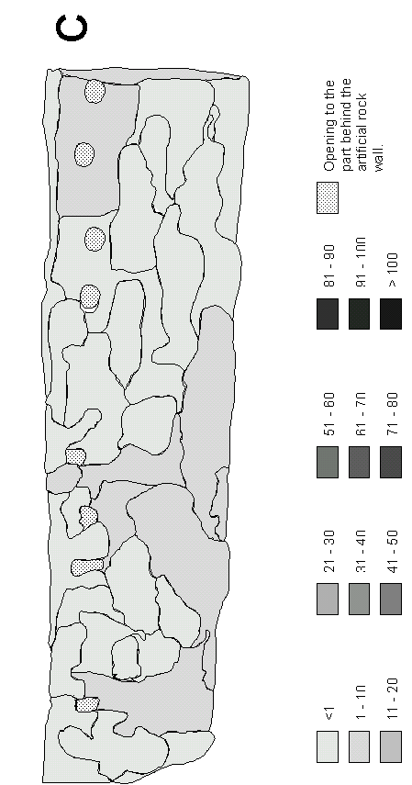
Fig. 3 Recruit densities of all populations per m². A) F1 generation of Favia fragum. B) F2 generation of F. fragum. C) F1 generation of Agaricia humilis.

Measurement of Environmental Factors

Substrate orientation was analyzed to estimate its influence on the recruitment of Agaricia humilis and Favia fragum in the exhibit tank. Substrate orientation was related to the surface relief fields and transects by categorizing them in (1) horizontal (0 < 45º), (2) vertical (45 – 90º), and (3) overhanging (> 90º). The category of each field and transect was determined by the general orientation of the surface area. Light intensity was measured in different water depths below the 1 KW and 2 KW HQI lamps using a spherical light sensor (LI-193SA; LICOR) connected to a LI-1400 datalogger (LICOR). The sensor measures the quantum flux between 400 and 700 nm (photosynthetically active radiance = PAR). The average amount of light was calculated by taking a measurement every second for duration of 30 s to minimize the influence of light refraction at the water surface.
To estimate the influence of established corals on the recruitment of the studied species, their mean density (surface area covered by corals m⁻²) was measured using the large transects.
Water chemistry was routinely monitored during the entire period. Analyses for calcium, nitrogen, phosphorous and magnesium were carried out using photo spectrometry (DR/4000U Photospectrometer, HACH Company U.S.A.).

Data Analysis
Analysis of variance (ANOVA) Model Typ III for a non-balanced design was originally planned to be used for data evaluation. As samples did not fulfill assumption of homogeneity of variance, the influence of substrate orientation on recruit density and colony size was studied with a Kruskal-Wallis ANOVA (SPSS 12.0). Whenever significance was detected, a posteriori comparisons of mean ranks of all pairs of groups were carried out following Siegel and Castellan (1988). Due to the topography of the artificial rock wall with almost only vertical and overhanging surfaces especially in the upper part of the tank, it is difficult to statistically study a potential influence of water depth on the population structure. Therefore I used the field maps to discuss possible influences.

RESULTS

In 3 subsequent counts, the method to divide the surface relief into fields showed a total of 146.7 ± 31.9 (mean ± SD) recruits of the F1 generation, 427 ± 87.6 (mean ± SD) recruits of the F2 generation in Favia fragum, whereas Agaricia humilis showed a total of 5 ± 1.2 (mean ± SD) recruits of the F1 generation and no F2 recruits. Using the transecting method (28 transects for F1, 21 transects for F2 generation), a total of 101 recruits of the F1 and 261 recruits of the F2 generation were found in F. fragum (see Fig. 1), whereas only 7 colonies of the F1 generation in A. humilis were counted in total (F2 generation: no recruits). F1 colonies (n = 64) of F. fragum had a colony surface of 5.48 ± 3.85 cm² (mean ± SD) with a maximum diameter of 3.12 ± 0.98 cm (mean ± SD), F2 recruits (n = 217) had a surface of 0.54 ± 0.53 cm² (mean ± SD) with a max. diameter of 0.83 ± 0.41 (mean ± SD). A. humilis recruits (n = 7) showed a surface of 7.15 ± 3.89 cm² (mean ± SD) and a max. diameter of 3.80 ± 1.14 cm (mean ± SD). The F1 specimens of both species were approx. 2 years old, when they were measured. Because of the low number of recruits in A. humilis, this species was not statistically analyzed.

The tank (see Fig. 2A) divided in 35 field sections of different surface orientation (Fig. 2B) clearly shows a dominance of vertical and overhanging surfaces. Fig 3A-C gives an overview of the densities of each population m⁻². When comparing mean densities per orientation category, calculated after the field method (Fig. 4B) with those of the transecting

method (Fig. 4A) similar tendencies are shown. Recruit densities were highest on horizontal surfaces (0 < 45˚), followed by vertical surfaces (45 – 90˚), and lowest on overhanging surfaces (> 90˚). Nevertheless, in both generations of F. fragum the absolute values of the means differ between both methods, especially on the horizontal and vertical surfaces. Recruit densities of F. fragum differ between differently oriented fields (Kruskal-Wallis ANOVA, F1: n = 35, H = 8.020, p = 0.018; F2: n = 35, H = 16.140, p < 0.001) and between differently oriented transects (Kruskal-Wallis ANOVA, F1: n = 28, H = 7.652, p = 0.022; F2: n = 21, H = 7.684, p = 0.021). In both assessment methods densities of the F1 generation were only significantly higher on horizontal surfaces compared to those on overhanging surfaces (Table 1). The analysis of the F2 generation showed similar tendencies, except for the field method, where densities on horizontal surfaces were significantly higher compared to vertical and overhanging surfaces (Table 1 and Fig 3). It has to be noted that the field method showed higher significance compared to the transect method. Higher densities (> 10 recruits m⁻²) of the F1 generation of F. fragum were found in all depth zones of the exhibit, highest densities of > 40 and > 100 recruits m⁻² occurred at horizontal surfaces on top and near the bottom of the tank (Fig. 3A). Similar tendencies are shown in the F2 generation, however, highest densities of > 50 recruits m⁻² can be observed more towards the center of the tank (Fig. 3B). It should be emphasized that the only horizontal surface area at the top of the rock wall represents a connection between the front and back part of the tank, where the parental colonies were maintained (Fig. 2B). More than half of the rock wall (to the left) reaches throughout the water surface. Additional connections to the back part are represented by several holes with a diameter of up to 30 cm in the upper part of the tank. Through these holes larvae could additionally reach the front part of the tank.
A
B
Fig. 4 Recruit densities for all populations depending on substrate orientation. Assessment using A) transects or B) field maps. Note logarithmic scale.

The colony size of the recruits was not dependent on the surface orientation (Kruskal-Wallis ANOVA, F1: n = 64, H = 2.424, p = 0.298; F2: n = 217, H = 0.798, p = 0.671) in both generations (see also Fig. 4). Maximum colony sizes occurred in all depths of the tank. Colony sizes highly varied between specimens of the F1 generation as indicated in Fig. 5. A mean growth rate of 0.16 ± 0.06 cm month⁻¹ (mean ± SD) was calculated for 10 colonies, which had a max. diameter of 2.94 ± 0.49 cm (mean ± SD) at the beginning of the monitoring period.

Light intensity was with 1537.33 ± 162.68 μmol m⁻² s⁻¹ (mean ± SD) highest below the 2KW lamps in a water depth of 0.1 m. Differences between different types of lamp decreased with increasing water depth (Fig. 6) and finally ranged between 561.37 ± 4.01 μmol m⁻² s⁻¹ (mean ± SD; 1KW HQI 6,000 K) and 283.57 ± 6.09 μmol m⁻² s⁻¹ (mean ± SD; 1KW HQI 20,000 K).

All water parameters are within natural limits except nitrate, which shows slightly higher levels (Table 2).

Using the large transects, I calculated a total coral cover of 4.69 % (including scleractinians, gorgonians and anemones).

Fig. 5 Colony size of the F1 and F2 generations of Favia fragum on different oriented surfaces (n_{F1} = 64, n_{F2} = 217; mean + SD).
Fig. 6 Light distribution in the exhibit below different light units. 2KW 6 K = 2,000 W HQI 6,000 K; 1 KW 6K = 1,000 W HQI 6,000 K; 1 KW 20 K = 1,000 W HQI 20,000 K

DISCUSSION

The population structure of Favia fragum and Agaricia humilis reflects their life history under the specific circumstances of an aquarium exhibit. The distribution of the F2 generation of F. fragum is the result of the number of released larvae, larval survivorship, settlement rate and early recruitment rate of juveniles. The distribution of the F1 generations of both species involves the whole recruitment process until the specimens reached sexual maturity (proven in the case of F. fragum, see below). The water chemistry of the exhibit shows a high water quality similar to field conditions. The higher nitrate concentrations are at levels that did not show growth limitation in captive corals (see Atkinson et al., 1995).
The applied methods seem to be appropriate to assess the different populations and generally reflect the same tendencies in the present study. However, the transect method showed the tendency to overestimate densities, whereas the field method might lead to an underestimation of the real population densities. Additionally, the latter method showed a relatively high standard deviation of approx. 20 % in 3 subsequent counts by one person. Whether to spot-check or to count all specimens in a particular case might depend on the size of the system and on logistical reasons, such as available equipment, the possibility to dive in a system, and available assistance (aquarium staff or students).

Planulation and Coral Plankton
From controlled planulation studies of the same populations (chapter 8) I can estimate that 30 colonies of Favia fragum release approx. 6,000 larvae compared to approx. 8,700 larvae in Agaricia humilis in 3 months. Under laboratory conditions (chapter 8), approx. 40 % of released planulae in F. fragum settled within 12 hr after release compared to less than 14.5 % in A. humilis. Within 12-36 hr after release, 55 % of the remaining larvae of F. fragum and 40 % of A. humilis settled. Larvae of F. fragum are generally negatively buoyant right after release (Carlon, 2002; personal observation), whereas those of A. humilis usually stay at the water surface for at least 12 hr (personal observation). Although the number of released larvae is higher in A. humilis, far less propagules will get the chance to attach due to a delay in settlement. The majority of larvae, especially of A. humilis will either be lost when passing the filtration units of the LSS or be consumed by planktivorous fish (Westneat and Resing, 1988). Additionally, established corals may consume high amounts of planktonic planulae (Fabricius and Metzner, 2004; see also Sebens et al., 1998). However, predation by planktivorous organisms is probably of minor importance in the present study due to the extremely low density of planktivorous fish and adult corals.
 |  |  | z | p
Fields | F1 | horizontal*vertical | 1.998 | 0.137
 |  | horizontal*overhanging | 2.802 | 0.015*
 |  | vertical*overhanging | 1.255 | 0.628
 | F2 | horizontal*vertical | 3.059 | 0.007**
 |  | horizontal*overhanging | 3.925 | <0.001***
 |  | vertical*overhanging | 1.487 | 0.411
Transects | F1 | horizontal*vertical | 2.133 | 0.100
 |  | horizontal*overhanging | 2.402 | 0.048*
 |  | vertical*overhanging | 0.358 | 1.000
 | F2 | horizontal*vertical | 0.650 | 1.000
 |  | horizontal*overhanging | 2.617 | 0.027*
 |  | vertical*overhanging | 2.280 | 0.068

Table 1 Favia fragum, F1 and F2 generation. Recruit density differences depending on substrate orientation. A posteriori multiple comparison after Siegel and Castellan (1988). Stars indicate significance level.

Settlement and Recruitment
Inhibition of settlement by established corals observed in the field (Maida et al., 1995; Fearon and Cameron, 1996) might play a minor role in the present study due to the low coral cover (< 5 %) as mentioned above. Other factors, such as (1) light (Mundy and Babcock, 1998), (2) filamentous algae (Tomascik, 1991) and (3) sedimentation (Hunte and Wittenberg, 1992) may have mainly influenced the settlement rate in the aquarium exhibit. The same effects may further influence the early development of juveniles as shown by various field studies (McCook et al., 2001; Babcock and Mundy, 1996; Wittenberg and Hunte, 1992; see also Falkowski et al., 1990).
(1) The F1 and F2 generation in Favia fragum showed highest densities on horizontal followed by vertical surfaces. Although not statistically tested, colony densities seemed to be independently of water depth. Colonies of the F1 generation of Agaricia humilis showed the same tendency. The overall light regime of the exhibit from the surface to a depth of 2 m represents the light distribution found in the field on light exposed surfaces in shallow waters to a depth of 20-30 m (Vermeij and Bak, 2002). Laboratory studies with larvae of the same populations showed high settlement rates (> 50%) even under lower light regimes than recorded in the exhibit (< 100 μmol m⁻² s⁻¹; see chapter 8), which confirms my hypothesis of depth independent settlement in the exhibit provided that other factors like

PO4-P | all in mg/l | 0.010 ± 0.005 | 0.0007 – 0.023⁽⁵⁾
Mg | all in mg/l | 1338.7 ± 20.9 | 1300.0⁽⁴⁾
Ca | all in mg/l | 457.4 ± 13.8 | 416.0⁽⁴⁾
NO3-N | all in mg/l | 1.2 ± 0.4 | 0.0016 – 0.016⁽⁵⁾
NO2-N | all in mg/l | 0.004 ± 0.001 | 0.0003 – 0.015⁽⁵⁾
NH3-N | all in mg/l | 0.001 ± 0.005 | 0.0003 -0,023⁽⁵⁾
Alkalinity | meq/l | 3.1 ± 0.6 | -
Salinity | ‰ | 36.0 ± 0.4 | 35.8 – 36.2⁽³⁾
pH |  | 8.0 ± 0.1 | 8.0 – 8.4⁽²⁾
DO | % | 100.4 ± 1.3 | -
Temp. | °C | 26.0 ± 0.4 | 25.4 – 29.0⁽¹⁾
 |  | Exhibit (± SD) | Field
Table 2. Water chemistry of the exhibit tank. Parameters were measured weekly, approximately 2 hr after the start of illumination. ⁽¹⁾ at Curaçao (Van Moorsel, 1983); ⁽²⁾ after Sorokin (1995); ⁽³⁾ at Curaçao (personal observation); ⁽⁴⁾ after Adey and Loveland (1998), ⁽⁵⁾ calculated after Delbeek and Sprung (1996)

dispersal are excluded. As a result, specimens are found in the exhibit under light conditions of a water depth, which does not correspond to the distribution of the species in the field (Szmant-Froehlich et al., 1985; Van Moorsel, 1983; Van den Hoek and Breeman, 1978). Depth-dependent settlement was shown for some scleractinians under laboratory conditions with light as a proxy for water depth (Mundy and Babcock, 1998). However, a recent study of Vermeij and Bak (2002) emphasizes the importance of the light regime of the microhabitat, which represents an environment of a few square centimeters to even only a few square millimeters. In the present study, the distribution of both species emphasizes the role of the microhabitat on the settlement and recruitment, which may offer low light intensities even in shallow waters. Therefore, other factors such as a limited supply of larvae in greater depths of the reef, higher competition by other benthic organisms (sponges, etc.) or lower growth rates under low light regimes might be important factors affecting the distribution of F. fragum and A. humilis in the field. Light intensity can change drastically within a range of a few centimeters due to the surface structure (orientation) of the microhabitat (Vermeij and Bak, 2002). These small scale differences were not assessed in the present study. Nevertheless, corals can neutralize low light levels till a species-specific limit by photoadaptation (Falkowski et al., 1990), which can explain a depth and orientation-independent colony size in the F1 and F2 population of F. fragum in the present study. It should be emphasized that corals can use other energy sources than their symbiotic zooxanthellae. The feeding of the fish population in the tank could be an additional food source for the studied corals. The max. growth rate of F. fragum and Agaricia humilis in laboratory tanks, where no additional organic food was added was less (< 1.0 mm month⁻¹; chapter 9) compared to the growth in systems with additional food sources such as live and deep frozen plankton (> 1.0 mm month⁻¹) (see chapter 11). However, the importance of planktonic food on coral growth and reproduction needs further investigation. In the present study colony growth was only monitored under one condition for a limited time of 5 months, therefore we can not determine whether the specimens of the F1 generations reached maturity at different time e.g. depending on different growth rates related to surface orientation respectively to light intensity. In general, growth rates are influenced by substrate orientation; highest rates may be found on horizontal (= light exposed) surfaces (Babcock and Mundy, 1996). Using the colony sizes measured approx. 2 years after larval settlement, I can estimate a mean growth rate of 0.13 mm month⁻¹ in F. fragum, which corresponds with extension rates under field conditions (Van Moorsel, 1988). Mean growth of A. humilis of 0.16 mm month⁻¹ was less than those observed in the field (2.4 mm month⁻¹; Van Moorsel, 1988). Further, I cannot exclude that growth rates can change over time and between different life stages (see Van Moorsel, 1988). Furthermore, some individuals of the F1 generation in F. fragum might have shown lower growth rates than the average and were still below a diameter of 2 cm, thus were assessed as F2 specimens.
(2) and (3) Although algal cover and sedimentation was not monitored, we observed certain tendencies. Total cover of Chlorophyta, Rhodophyta and cyanobacteria varied over time, especially cyanobacteria temporarily bloomed in certain areas of the tank where water movement was less turbulent. Sediments accumulated in these regions of the tank as well. Sediments were removed successively once a month, whereas cyanobacteria were removed whenever necessary. Sedimentation occurred mainly on horizontal surfaces, whereas cyanobacteria appeared independent of orientation and light intensity on all surfaces of low flow regimes. The presence of herbivorous grazers kept green algal turfs short, which favored the growth of crustose coralline algae, which may induce settlement in scleractinians (Morse et al., 1996; Negri et al., 2001). Sedimentation and algal growth limit coral recruitment on horizontal surfaces in the field (Babcock and Mundy, 1996; Hunte and Wittenberg, 1992; Tomascik, 1991; Wittenberg and Hunte, 1992). These negative influences can be minimized in captivity as shown in the present study. However, the spatial distribution, especially of the F2 generation of F. fragum shown in the field maps, shows higher recruit densities in the center of the tank, where highest turbulence was present before the pneumatic valves were installed. Research on the influence of turbidity on the settlement and recruitment of corals in the aquarium environment would help to better understand captive reproduction.
In conclusion, the extremely high annual recruitment rate of F. fragum (F2 generation: 137 recruits m⁻² with field method, 272 recruits m⁻² with transects) compared to a general annual recruitment of scleractinians of 5 – 10 recruits m⁻² (Sorokin, 1995) can be explained by the favorable conditions of the studied exhibit: low predation, low competition by other benthic cnidarians, reduction of sedimentation and algal growth, appropriate light levels and high water quality. Nevertheless, the extremely low recruitment rate of A. humilis emphasizes species-specific limitation under captive conditions. Such differences may limit captive reproduction to a degree that although reproduction occurs, no recruitment is observed.

Sexual Maturity of F1 Generations
When looking at the massive appearance of F2 recruits in Favia fragum 18 months after the field colonies were introduced in the system, specimens of the F1 generation reached sexual maturity approx. 12 months after birth, some with higher growth rates probably even earlier. This calculation corresponds with field observations that showed initial reproduction at a colony size of 5 – 10 polyps (diameter of approx. 1 – 1.5 cm) (Szmant-Froehlich et al., 1985). Although not investigated in the present study, specimens of the F2 generation might have reached sexual maturity as well, due to a colony size of > 1.5 cm of at least some individuals. Agaricia humilis may release larvae at a size of 2.8 cm in diameter (Van Moorsel, 1983). In the present study the direct evidence of planulation in the F1 generation of F. fragum was given by collecting larvae after specimens were transplanted on a certain larval collection set up (chapter 6); obtained larvae settled successfully (unpublished data).
When looking at the colony sizes of the F1 recruits of Agaricia humilis in the present study (max. diameter recorded: 5.3 cm), at least some of the assessed specimens should have reached maturity as well. However, no recruits were found until the present date. If we assume that gametes were developed, a reason might be the low population density, which can lead to ineffective sperm transfer and therefore to a lack of fertilization (Morse et al., 1996). The few recruits in the exhibit were left undisturbed and were not used for further investigation to determine whether gametes were produced or whether larvae were released. Assuming the latter, the relatively low amount of propagules in combination with a species specific delay in settlement shown for A. humilis under captive conditions could be another explanation for the lack of a F2 generation. At the zoos of Hamburg, London and Rotterdam recruitment rates of A. humilis were relatively low (chapter 11). The overall sensitivity of A. humilis regarding reproduction in captivity contradicts with its high abundance in shallow and highly disturbed natural reef areas (Van Moorsel, 1983; see chapter 8), thus needs further investigation.

REFERENCES

Adey WH, Loveland K. 1998. Dynamic aquaria: building living ecosystems. London: Academic Press. 498 p.
Atkinson MJ, Carlson B, Crow GL. 1995. Coral growth in high-nutrient, low-pH seawater: a case study of corals cultured at the Waikiki Aquarium, Honolulu, Hawaii. Coral Reefs 14:215-223.
Alvarez J, Garcia M. 2001. The Oceanic Park of Valencia. In Ounais N, Theron D, editors. Proceedings Fifth International Aquarium Congress, Monaco. Bulletin de l’Institut Oceanographique, Monaco, No. special 20(2):175-180.
Babcock RC, Mundy C. 1996. Coral recruitment: consequences of settlement choice for early growth and survivorship in two scleractinians. J Exp Mar Biol Ecol 206:179-201.
Carlon DB. 2002. Production and supply of larvae as determinants of zonation in a brooding tropical coral. J Exp Mar Biol Ecol 268:33-46.
Carlson BA. 1999. Organism responses to rapid changes: what aquaria tell us about nature. Am Zool 39: 44-55.
Delbeek JC, Sprung J. 1996. Das Riffaquarium. Vol. 1. Coconut Grove: Ricordea Publishing. p. 544.
Fabricius KE, Metzner J. 2004. Scleractinian walls of mouths: predation on coral larvae by corals. Coral Reefs 23:245-248.
Falkowski PG, Jokiel PL, Kinzie III RA. 1990. Irradiance and corals. In Dubinsky Z, editor. Ecosystems of the world vol 25, coral reefs. Amsterdam: Elvesier, p 89-107.
Fearon RJ, Cameron AM. 1996. Larvotoxic extracts of the hard coral Goniopora tenuidens: allelochemicals that limit settlement of potential competitors? Toxicon 34(3):361-367.
Harrison PL, Wallace CC. 1990. Reproduction, dispersal and recruitment of scleractinian corals. In Dubinsky Z, editor. Ecosystems of the world vol 25, coral reefs. Amsterdam: Elvesier, p 133-207.
Harriott V J, Fisk DA. 1987. A comparison of settlement plate types for experiments on the recruitment of scleractinian corals. Mar Ecol Prog Ser 37:201-108.
Hunte W, Wittenberg M. 1992. Effects of eutrophication and sedimentation on juvenile corals. II. Settlement. Mar Biol 114:625-631.
Janse M, Wensing J. 2001. Burgers’ Ocean, a new Indo-Pacific ecodisplay at Burgers’ Zoo, Arnhem, The Netherlands. In Ounais N, Theron D, editors. Proceedings Fifth International Aquarium Congress, Monaco. Bulletin de l’Institut Oceanographique, Monaco, No. special 20(2): 331-334.
Maida M, Sammarco PW, Coll JC. 1995. Effects of soft corals on scleractinian coral recruitment. I: Directional allelopathy and inhibition of settlement. Mar Ecol Prog Ser 121:191-202.
McCook LJ, Jompa J, Diaz-Pulido G. 2001. Competition between corals and algae on coral reefs: a review of evidence and mechanism. Coral Reefs 19: 400-417.
Morse ANC, Iwao K, Baba M, Shimoike K, Hayashibara T, Omori M. 1996. An ancient chemosensory mechanism brings new life to coral reefs. Biol Bull 191:149-154.
Mundy CN, Babcock RC. 1998. Role of light intensity and spectral quality in coral settlement: Implications for depth-dependent settlement. J Exp Mar Biol Ecol 223:235-255.
Negri AP, Webster NS, Hill RT, Heyward AJ. 2001. Metamorphosis of broadcast spawning corals in response to bacteria isolated from crustose algae. Mar Ecol Prog Ser 223:121-131.
Sebens KP, Grace SP, Helmuth B, Maney Jr. EJ, Miles JS. 1998. Water flow and prey capture by three scleractinian corals, Madracis mirabilis, Montastraea cavernosa and Porites porites, in a field enclosure. Mar Biol 131:347-360.
Siegel S, Castellan NJ. 1988. Nonparametric statistics for the behavioral sciences. 2nd ed. New York: McGraw-Hill, 399 p.
Sorokin YI. 1995. Coral reef ecology. 102. Ecological studies. 2nd printing. Berlin: Springer, 465 p.
Szmant-Froehlich A, Reutter M, Riggs L. 1985. Sexual reproduction of Favia fragum (Esper): lunar patterns of gametogenesis, embryogenesis and planulation in Puerto Rico. Bull Mar Sci 37(3):880-892.
Tomascik T. 1991. Settlement patterns of Caribbean scleractinian corals on artificial substrata along a eutrophication gradient, Barbados, West Indies. Mar Ecol Prog Ser 77:261-269.
Van Moorsel GWNM. 1983. Reproductive strategies in two closely related stony corals (Agaricia, Scleractinia). Mar Ecol Prog Ser 13:273-283.
Van Moorsel GWNM. 1988. Early maximum growth of stony corals (Scleractinia) after settlement on artificial substrata on a Carribbean reef. Mar Ecol Prog Ser 50:127-135.
Van den Hoek C, Breeman AM. 1978. The distribution of algae, corals and gorgonians in relation to depth, light attenuation, water movement and grazing pressure in the fringing coral reef of Curaçao, Netherlands Antilles. Aquat Bot 5:1-46.
Vermeij MJA, Bak RPM. 2002. How are coral populations structured by light? Marine light regimes and the distribution of Madracis. Marine Ecology Progress Series 233:105-116.
Westneat MW, Resing J. 1998. Predation on coral spawn by planktivorous fish. Coral Reefs 7:89-92.
Wittenberg M, Hunte W. 1992. Effects of eutrophication and sedimentation on juvenile corals. I. Abundance, mortality and community structure. Mar Biol 112: 131-138.

